Notes from EcoSeminar

Google doc: <https://docs.google.com/document/d/1RGRQ0GJIrEvwiPdS3nzJTx8GjN5XhI0w-pyGW5w7YYc/edit>

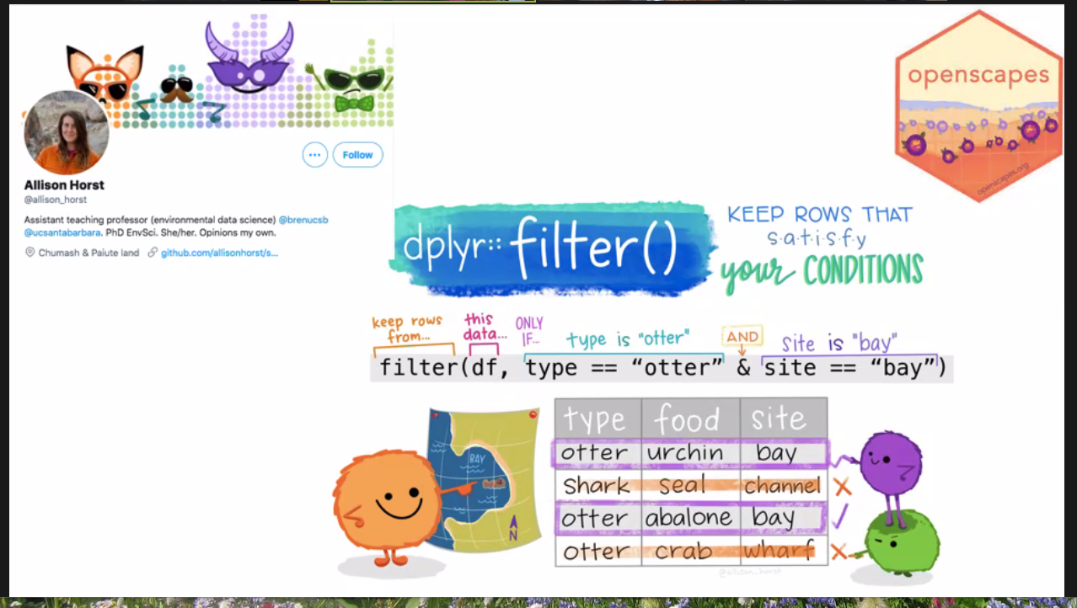



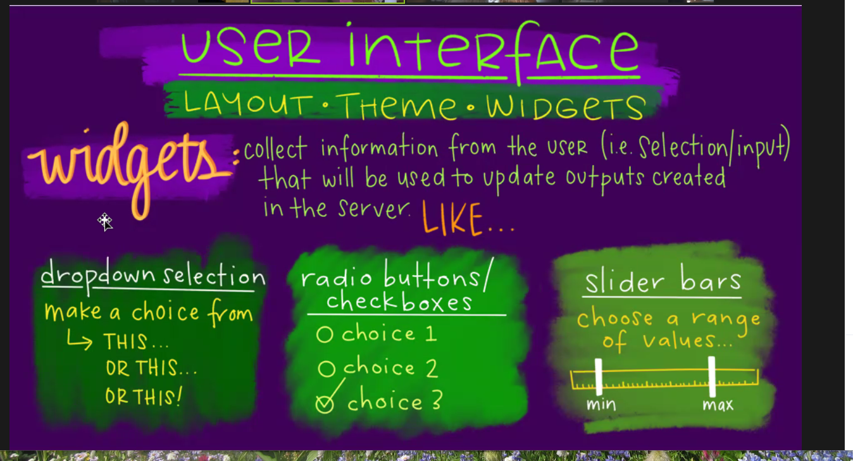

More widgets in the google doc: <https://docs.google.com/document/d/1RGRQ0GJIrEvwiPdS3nzJTx8GjN5XhI0w-pyGW5w7YYc/edit>

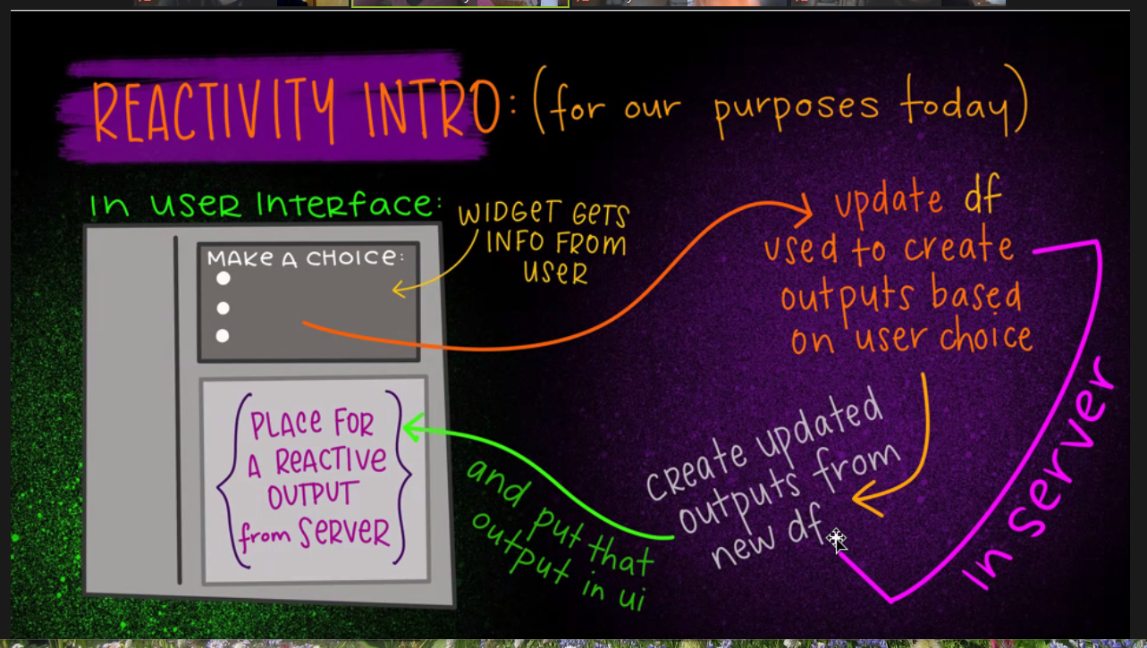

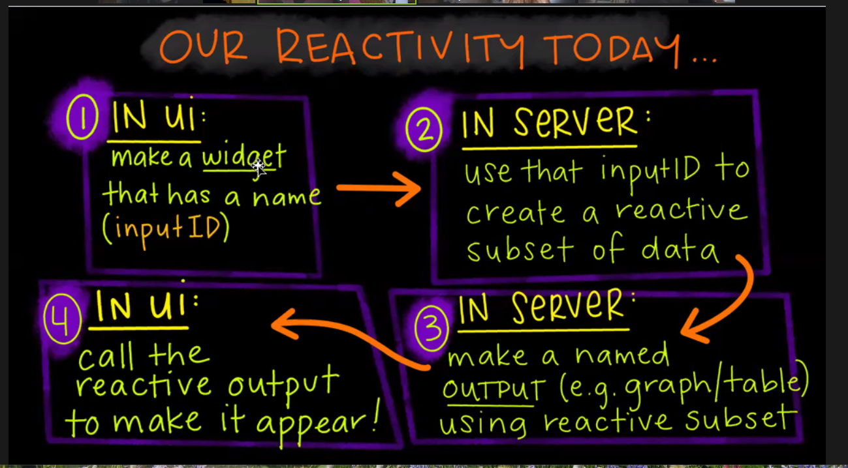

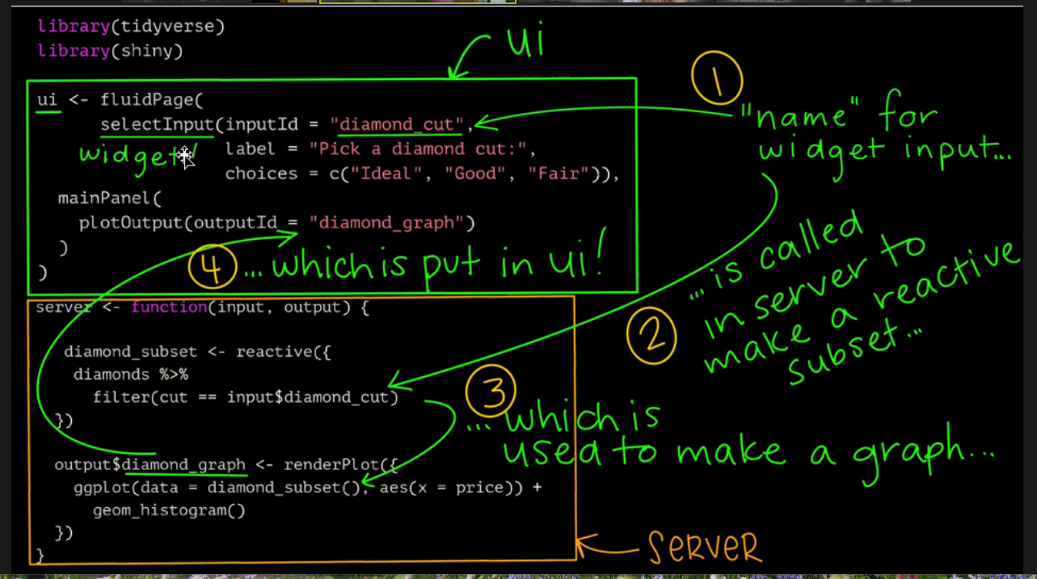

A few more visualizations:

<https://oharascience.shinyapps.io/bd_chi_shiny/>

from this paper: <https://science-sciencemag-org.offcampus.lib.washington.edu/content/372/6537>